**CASE STUDY**

**ON**

**AWS CLOUDFORMATION**

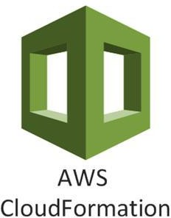

**INTRODUCTION**

**AWS CloudFormation** is a service that helps you model and set up your AWS resources so that you can spend less time managing those resources and more time focusing on your applications that run in AWS. You create a template that describes all the AWS resources that you want (like Amazon EC2 instances or Amazon RDS DB instances), and CloudFormation takes care of provisioning and configuring those resources for you. You don't need to individually create and configure AWS resources and figure out what's dependent on what; CloudFormation handles that. The below diagram demonstrate how CloudFormation can help.

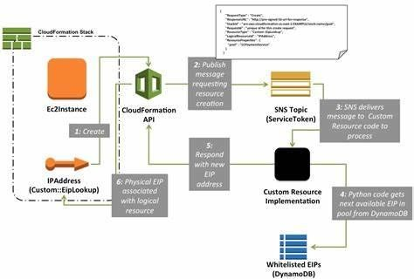

**HANDS ON**

**Step 1:** Search **cloudformation** in search bar. Then click on

**create stack**

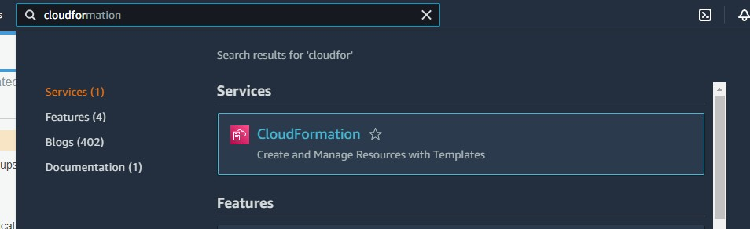

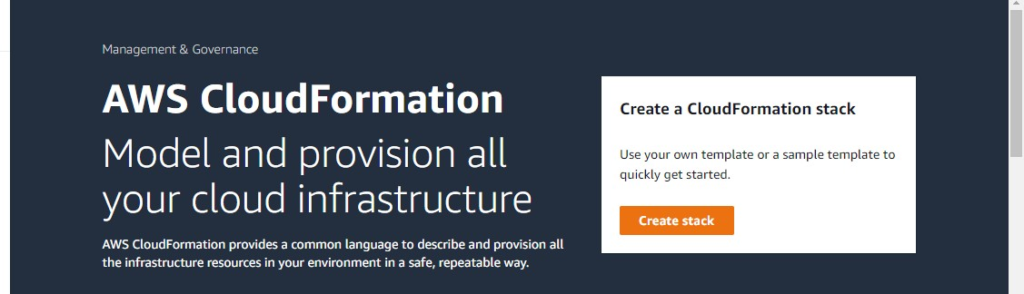

**Step 2:** Now you will land to a page where you can design your template or upload the predefined template for the services which you want to create. For this demo I am uploading the template for creating a EC2 instance.

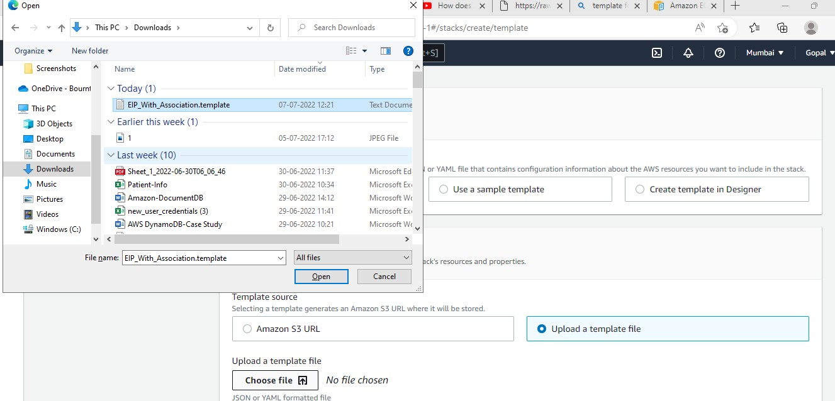

**Step 3:** when you upload a template it will save it **in s3** bucket . Also you can see the design of your template by clicking on **view in designer**

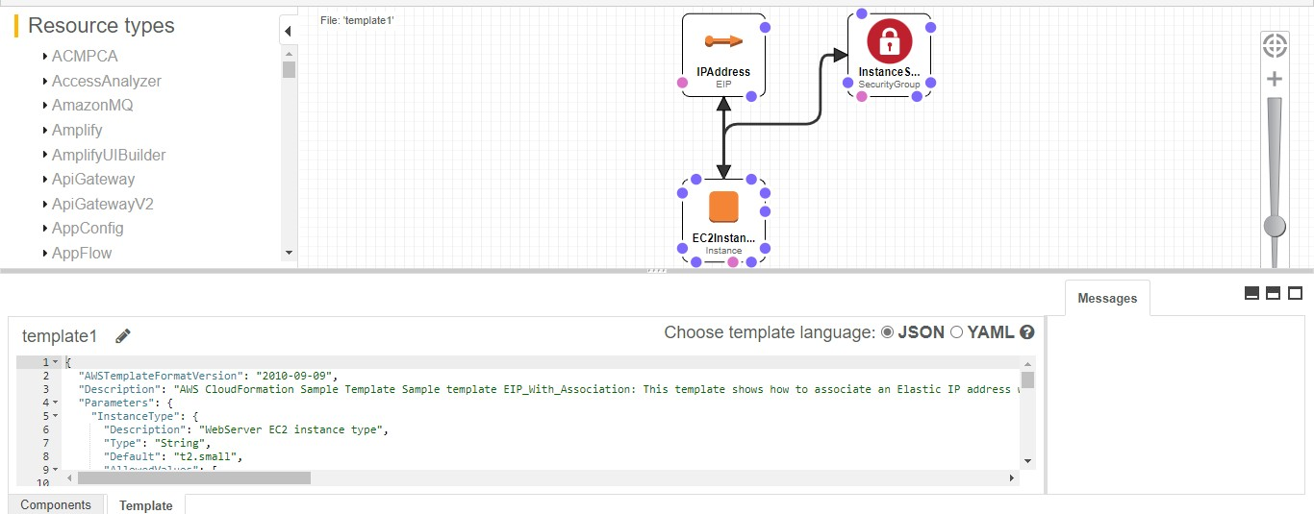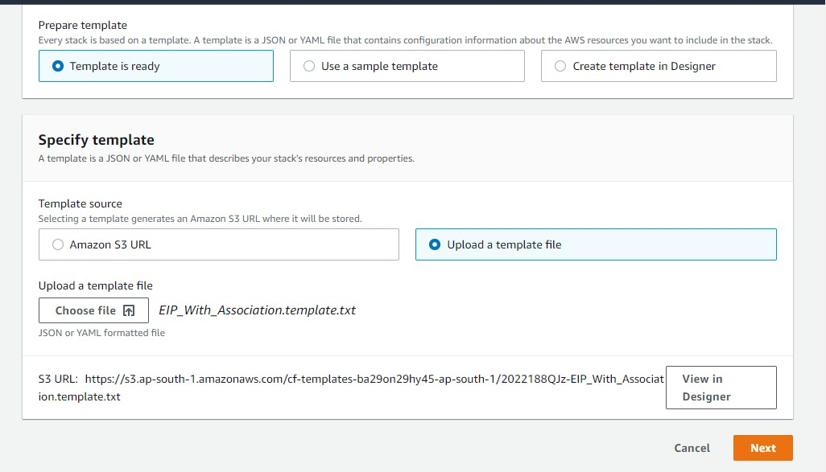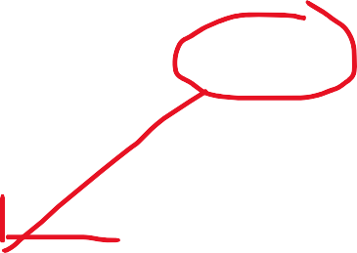

**Step 4:** Now click on next and give **stack name**, choose the **instance type,** give **key pair** and click on **next**

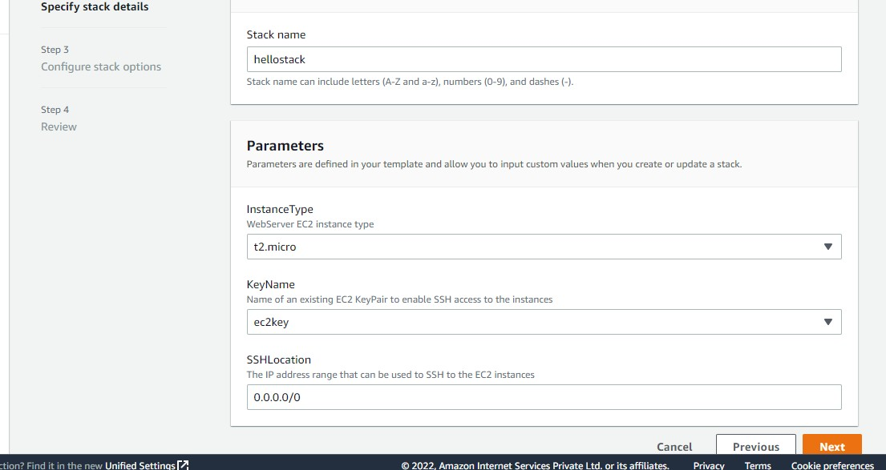

**Step 5:** Give the tags and keep all things as default and

then click on next

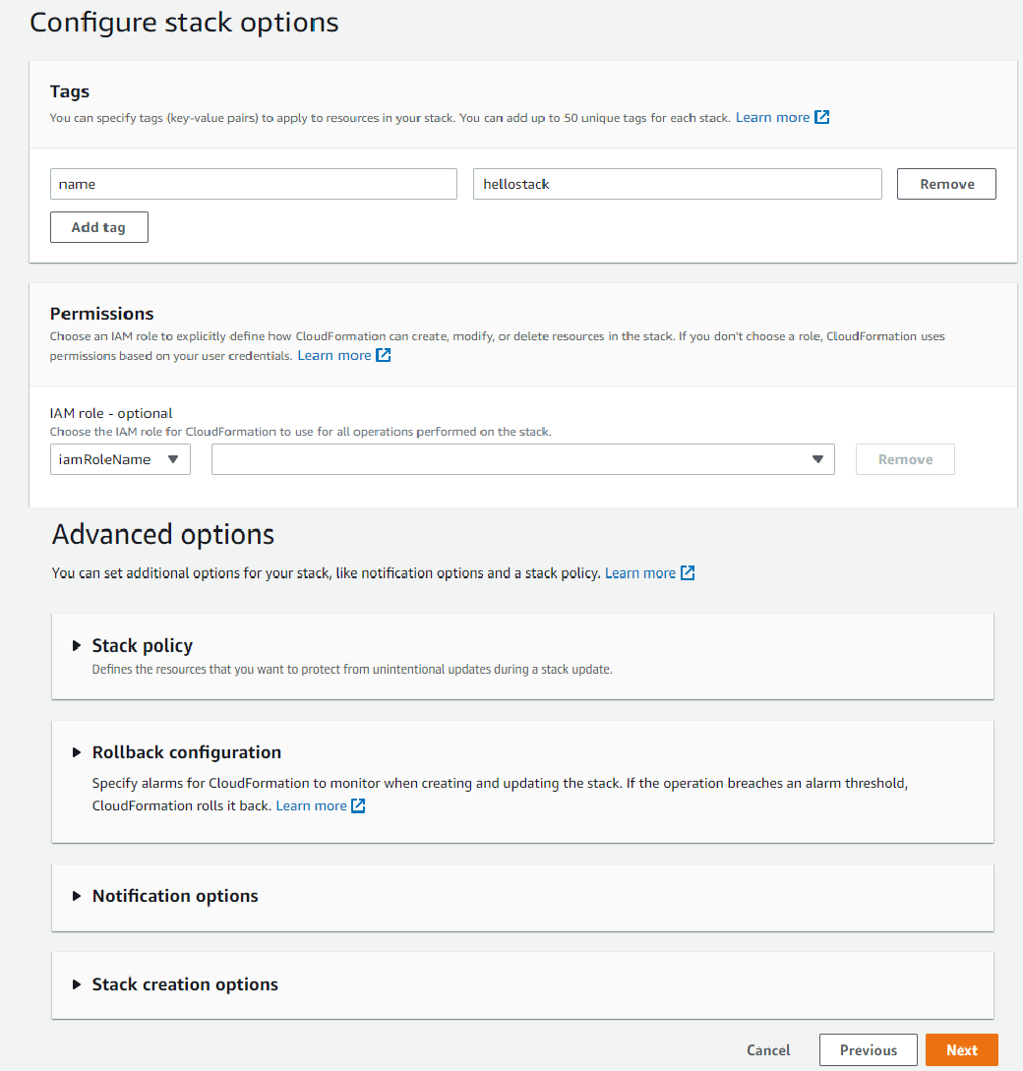

**Step 6:** After reviewing your stack click on **create stack**

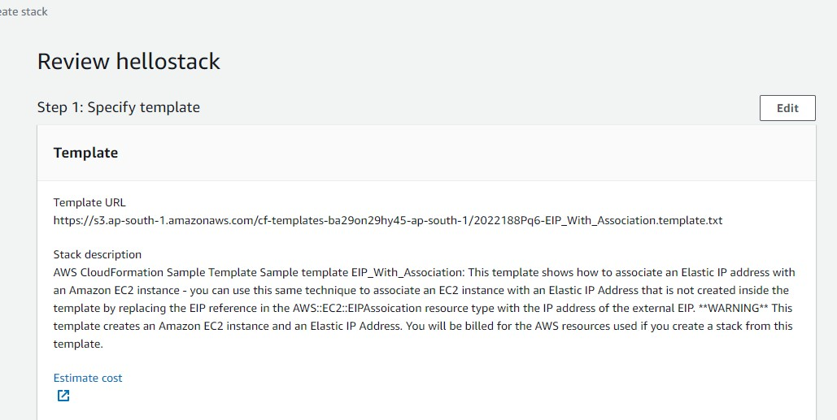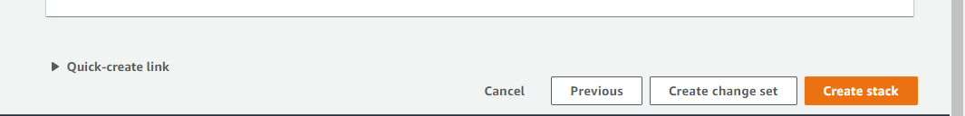

**Step 7:** You can the status of your events progress also when you open your ec2 instance you can see creating of it

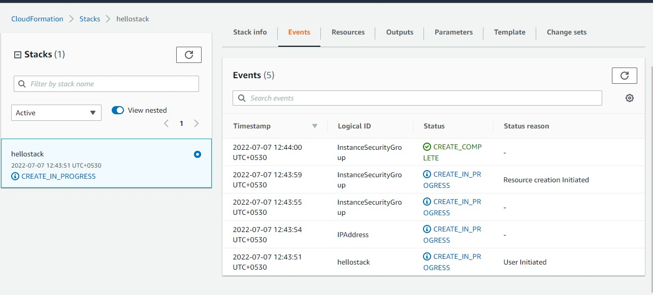

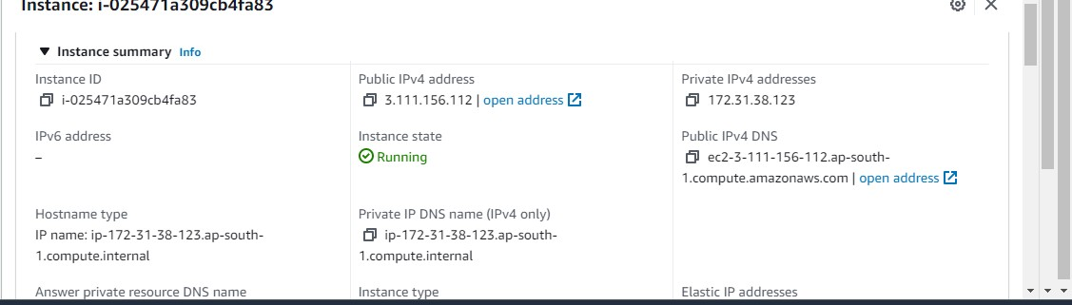**Step 8:** Once the stack is created you can see your instance in the running stage and can see the security groups and IP address

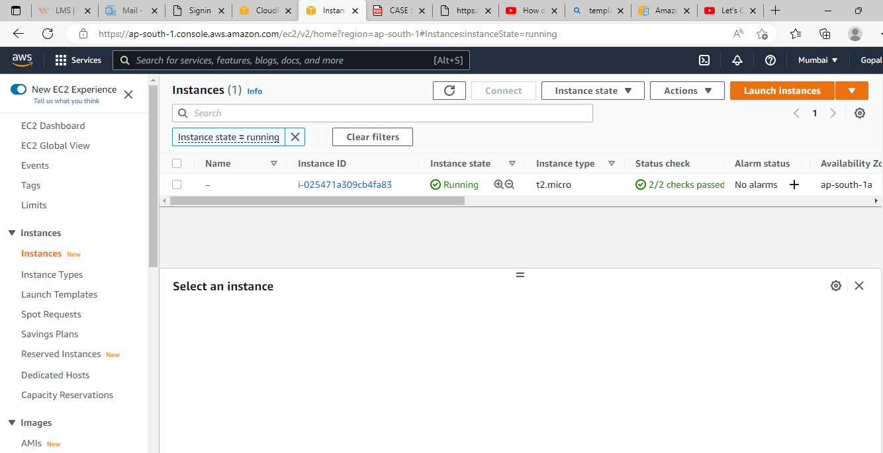

**Step 9:** When you delete your stack you can observe your instance to be terminating

